***A Mini Project Synopsis on***

**AQI TRACKER**

**S.E. - I.T Engineering**

**Submitted By**

**VAISHNAVI BHALERAO 21204007**

**MAYURESH KALKAR 21204010**

**SAHIL JADHAV 21204013**

**PALLAVI TAMBE 21204001**

**Under The Guidance Of**

**<Ganesh Gourshete >**



**DEPARTMENT OF INFORMATION TECHNOLOGY**

A.P. SHAH INSTITUTE OF TECHNOLOGY

G.B. Road , Kasarvadavali, Thane (W), Mumbai-400615

UNIVERSITY OF MUMBAI

**Academic year : 20201-22**

**CERTIFICATE**

This to certify that the Mini Project report on **AQI TRACKER**

has been submitted by **VAISHNAVI BHALERAO** (**21204007**), **MAYURESH KALKAR** (**21204010**) and **SAHIL JADHAV** (21204013) **PALLAVI TAMBE** (21204001) who are a Bonafede students of A. P. Shah Institute of Technology, Thane, Mumbai, as a partial fulfilment of the requirement for the degree in **Information Technology**, during the academic year **2020-2021** in the satisfactory manner as per the curriculum laid down by University of Mumbai.

Prof. Ganesh Gourshete

Guide

Prof. Kiran Deshpande Dr. Uttam D.Kolekar

Head Department of Information Technology Principal

External Examiner(s)

1.

2.

Place:A.P.Shah Institute of Technology, Thane

Date:

**TABLE OF CONTENTS**

1. Introduction.......................................................................................................... 1
   1. Purpose..................................................................................................... 1
   2. Objectives................................................................................................. 1
   3. Scope........................................................................................................ 2
2. Problem Definition………………….................................................................... 3
3. Proposed System………....................................................................................... 4
   1. Features and Functionality…………………………………………………..4
4. Project Outcomes.................................................................................................. 7
5. Software Requirements ........................................................................................ 8
6. Project Design........................................................................................................9
7. Project Scheduling..................................................................................................15
8. Conclusion..............................................................................................................16

References

Acknowledgement

1**.Introduction**

In addition to land and water, air is the prime resource for sustenance of life. With the technological advancements, a vast amount of data on ambient air quality is generated and used to establish the quality of air in different areas. The large monitoring data result in encyclopaedic volumes of information that neither gives a clear picture to a decision maker nor to a common man who simply wants to know how good or bad the air is? One way to describe air quality is to report the concentrations of all pollutants with acceptable levels (standards). As the number of sampling stations and pollution parameters (and their sampling frequencies) increase, such descriptions of air quality tend to become confusing even for the scientific and technical community.

As for the general public, they usually will not be satisfied with raw data, time series plots, statistical analyses, and other complex findings pertaining to air quality. The result is that people tend to lose interest and can neither appreciate the state of air quality nor the pollution mitigation efforts by regulatory agencies. Since awareness of daily levels of urban air pollution is important to those who suffer from illnesses caused by exposure to air pollution, the issue of air quality communication should be addressed in an effective manner. Further, the success of a nation to improve air quality depends on the support of its citizens who are well-informed about local and national air pollution problems and about the progress of mitigation efforts.

To address the above concerns, the concept of an Air Quality Index (AQI) has been developed and used effectively in many developed countries for over last three decades (USEPA 1976, 2014; Ontario, 2013; Shenfeld, 1970). An AQI is defined as an overall scheme that transforms weighted values of individual air pollution related parameters (SO2, CO, visibility, etc.) into a single number or set of numbers. There have not been significant efforts to develop and use AQI in India, primarily due to the fact that a modest air quality monitoring programme was started only in 1984 and public awareness about air pollution was almost non-existent. The challenge of communicating with the people in a comprehensible manner has two dimensions: (i) translate the complex scientific and medical information into simple and precise knowledge and (ii) communicate with the citizens in the 2 historical, current and futuristic sense. Addressing these challenges and thus developing an efficient and comprehensible AQI scale is required for citizens and policy makers to make decisions to prevent and minimize air pollution exposure and ailments induced from the exposure.

**1.1 Purpose**

The air quality index (AQI) is an index for reporting air quality on a daily basis. It is a measure of how air pollution affects one's health within a short time period. The purpose of the AQI is to help people know how the local air quality impacts their health. The Environmental Protection Agency (EPA) calculates the AQI for five major air pollutants, for which national air quality standards have been established to safeguard public health.

**1.**Ground-level ozone

**2.**Particle pollution/particulate matter (PM2.5/pm 10)

**3.** Carbon Monoxide

**4.**Sulfur dioxide

**5.** Nitrogen dioxide

The higher the AQI value, the greater the level of air pollution and the greater the health concerns. The concept of AQI has been widely used in many developed countries for over the last three decades. AQI quickly disseminates air quality information in real-time.

1.2 Objectives

The project aims to achieve the following:

* Inform public regarding overall status of air quality through a summation parameter that is easy to understand;
* Inform citizens about associated health impacts of air pollution exposure
* Rank cities/towns for prioritizing actions based on measure of AQI.
* Comparing air quality conditions at different locations/cities.
* It also helps in identifying faulty standards and inadequate monitoring programmes.
* AQI helps in analysing the change in air quality (improvement or degradation).
* AQI informs the public about environmental conditions. It is especially useful for people suffering from illnesses aggravated or caused by air pollution.

1.3 Scope

The Scope of the project are as follows:

* Review of available AQIs including international practices.
* Suggest health impact threshold limits for eight parameters for which short-term air quality standards are prescribed.
* Develop a uniform AQI considering objectives, health impacts, air quality standards, existing and future monitoring scenario including parameters, method and frequency of measurements, and other relevant aspects.
* Suggest qualitative description of air quality and associated likely health impacts for different AQI values.
* Evaluate AQI with data from a few major cities and towns.
* Develop web-based system for dissemination of AQI to public using current and historical air quality database and
* Finalize AQI and dissemination system in consultation with leading air quality experts, medical professionals working in the field of air pollution health impacts, State Pollution Control Boards and other stakeholders

**2.Problem Definition**

From smog hanging over cities to smoke inside the home, **air pollution poses a major threat to health and climate**. Ambient air pollution accounts for an estimated 4.2 million deaths per year due to stroke, heart disease, lung cancer, lung cancer, acute and chronic respiratory diseases.

6 PROBLEMS OF POLLUTION ON HEALTH.

* Pollution has a large impact on human health. ...
* The health impacts from many pollutants are completely.
* Pollution disproportionately kills the poor and the vulnerable. ...
* Pollution is closely tied to climate change and biodiversity. ...
* Pollution is neglected. ...
* Pollution is costly.
  + 3.Proposed System

3.1 Features and Functionality

* Air Quality Index
* Climate
* Temperature
* Percentage of present gases

4. Project Outcomes

The AQI scale used for indexing the real-time pollution.

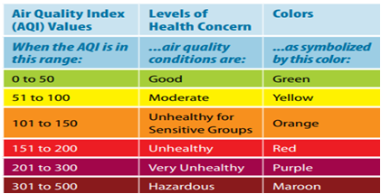

**Air Quality Index Categories**

* **Good (0–50) -**Minimal Impact
* **Satisfactory (51–100) -**May cause minor breathing difficulties in sensitive people.
* **Moderately polluted (101–200)** - May cause breathing difficulties in people with lung disease like asthma, and discomfort to people with heart disease, children and older adults.
* **Poor (201–300) -** May cause breathing difficulties in people on prolonged exposure, and discomfort to people with heart disease
* **Very Poor (301–400) -** May cause respiratory illness in people on prolonged exposure. Effect may be more pronounced in people with lung and heart diseases.
* **Severe (401-500) -** May cause respiratory issues in healthy people, and serious health issues in people with lung/heart disease. Difficulties may be experienced even during light physical active

5. Software Requirements

* VScode
* Python 3.0.1
* IDLE
* Python, Tkinter
* Database: xampp server

6. Project Design

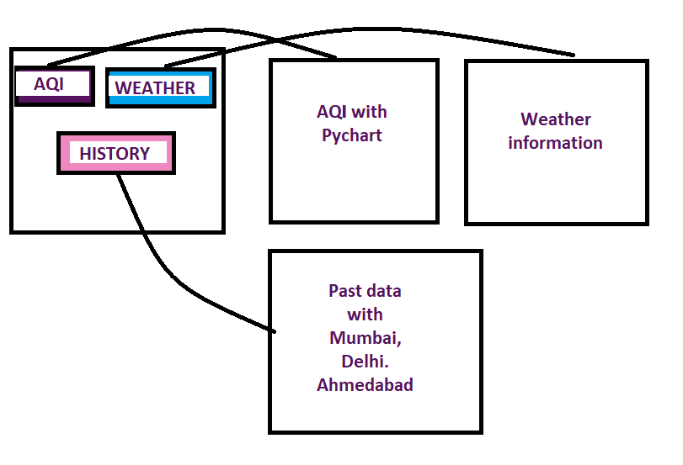

7. Project Scheduling

|  |  |  |  |
| --- | --- | --- | --- |
| Sr.no | Group members | Time duration | Work to be done |
| 1 | Vaishnavi  Bhalerao | 1st,2nd week of march | Implementing 1st module/ functionality  (Designing the AQI & database)  Testing 1st module |
| 2 | Mayuresh  kalkar | 3rd week of march | Implementing 2nd module/ functionality  (Designing the weather api & database)  Testing 2nd module |
| 3 | Pallavi  Tambe | 1st week of April | Implementing 3rd module/ functionality  (Designing the pie chart & also help in GUI) |

|  |  |  |  |
| --- | --- | --- | --- |
| 4 | Sahil jadhav |  |  |

8.Conclusion

* In conclusion the project helpsthe public about environmental conditions. It is especially useful for people suffering from illnesses aggravated or caused by air pollution.
* We started off with a AQI level of 178 (Unhealthy) for the city of Beijing, this level was too high due to the fact that it is one of the most populated cities in the world without a "green culture".
* By analyzing the causes and control chart we implemented a solution for this process for which we were able lower the AQI to 98 which falls into the moderate level.
* We Improved the pie chart by deleting the out-of-control points and recalculating the control limits.
* Once the process was stable, we calculated the process capability analysis to understand the sigma level and observe the performance of the control chart.

**Reference**

* <https://www3.epa.gov/airnow/aqi_brochure_02_14.pdf> [USEPA : AQI: A Guide to Air Quality and Your Health]
* <http://pib.nic.in/newsite/PrintRelease.aspx?relid=110654>  [MoEFCC]
* <http://safar.tropmet.res.in/AQI-47-12-Details>
* <http://www.indiaenvironmentportal.org.in/files/file/Air%20Quality%20Index.pdf> (National Ambient Air Quality Standards, CPCB)
* <https://www.tropmet.res.in/~lip/Publication/RR-pdf/RR-127.pdf>
* <https://intermountainhealthcare.org/blogs/topics/live-well/2015/02/know-the-air-quality-index-and-how-to-use-it/>
* <https://airnow.gov/index.cfm?action=aqibasics.aqi>